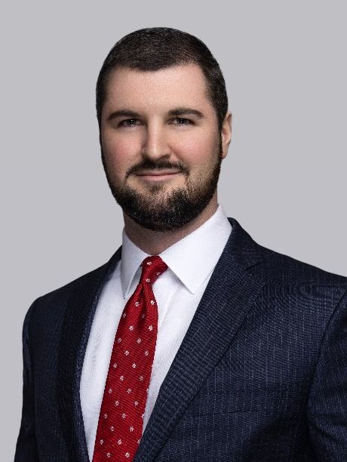

DEREK J. MARKLE, Associate
412.456.2878 | djm@muslaw.com

Derek represents lending and financial institutions in all aspects of corporate, commercial, real estate and banking matters, including lending transactions, consultation and advice on transaction structuring, drafting and negotiation of loan documentation, analysis of title insurance issues and risks, intercreditor and participation agreements and related lending matters. Derek’s representation of these clients extends to workout and debt restructuring arrangements, including foreclosure, bankruptcy and litigation proceedings. Derek also represents lenders in all aspects of equipment finance transactions including negotiation and documentation of syndications and other lease related financing transactions.
Practice Groups
- Real Estate & Lending
- Corporate & Business Law
- Creditors’ Rights & Bankruptcy
Education
- J.D., Dickinson School of Law of the Pennsylvania State University, 2016
- B.A., Saint Francis University, 2013 – magna cum laude
Bar Admissions
- Pennsylvania
He counsels clients on general corporate governance matters including business planning and structuring, choice of entity issues, and real estate issues that arise in the course of corporate transactions.
Derek also represents real estate investors and developers, as well as other individual and corporate clients in the negotiation and drafting of real estate contracts and documents, commercial lease agreements, purchase and sale agreements, and transactions involving the acquisition and disposition of assets, including purchase, sale, construction, renovation and financing of all types of commercial real estate transactions, such as retail properties, residential development projects, office complex development projects, and other mixed-use properties.
Representative Matters
Lending and Financing Transactions
- Regularly represents lenders and borrowers in multi-million-dollar financing transactions.
- Regularly represents lenders in residential development loans and accompanying builder’s lines of credit.
- Represented a national lender in connection with equipment financing transactions ranging from $20 million to $35 million.
Real Estate Transactions
- Represented regional financial institutions in connection with the acquisition of potential branch locations and disposition of former branch locations.
- Regularly represents developers and financial institutions in connection with drafting and negotiation of ground leases and real estate purchase and sale agreements.
- Regularly represents developers, landlords, and tenants in connection with drafting and negotiation of lease agreements for commercial general, retail, and medical office space.

DEREK J. MARKLE, Associate
412.456.2878 | djm@muslaw.com

Representative Matters (continued)
Bankruptcy, Workout, Creditors Rights and Litigation Matters
- Regularly represents lenders and other creditors in commercial loan workouts and bankruptcy related matters.
- Regularly represents a national equipment financing and leasing company in enforcement of rights under leases and related workout matters.
- Represented a national health and nutrition company in connection with the enforcement of rights under franchise and purchasing agreements.
- Represented financial institutions and credit unions in numerous data breach class action lawsuits throughout the United States.
Corporate Transactions
- Regularly represents business owners and individuals to advise on entity formation, corporate governance, entity restructuring and other day-to-day business and corporate issues.
- Represented business owner in connection with negotiation of asset purchase agreement and subsequent sale of multiple Edible Arrangements franchises.

Awards/Honors
- Westmoreland County Bar Association, Wayne R. Donahue Memorial Scholarship Recipient, 2013, 2014
- Selected to represented Penn State Dickinson in the Academy of Trial Lawyers of Allegheny County (Gourley Cup) Mock Trial Competition
Court Admissions
- Supreme Court of Pennsylvania
- United States District Court for the Western District of Pennsylvania
Community Involvement
- Allegheny County Bar Association, Member
- Junior Achievement of Western Pennsylvania Young Professionals Board, Member
- Phi Kappa Theta Fraternity – Nationwide Peer Accountability Committee, Chairman

In his free time, Derek enjoys cooking, golfing, skiing, and biking and is an avid Penn State football fan.

